INFOSYS SPRINGBOARD 6.0

Name- Swapnil Pal
Topic- Smart Energy Consumption Analysis and Prediction using Machine Learning with Device-Level Insights
Documentation for Week 3-4

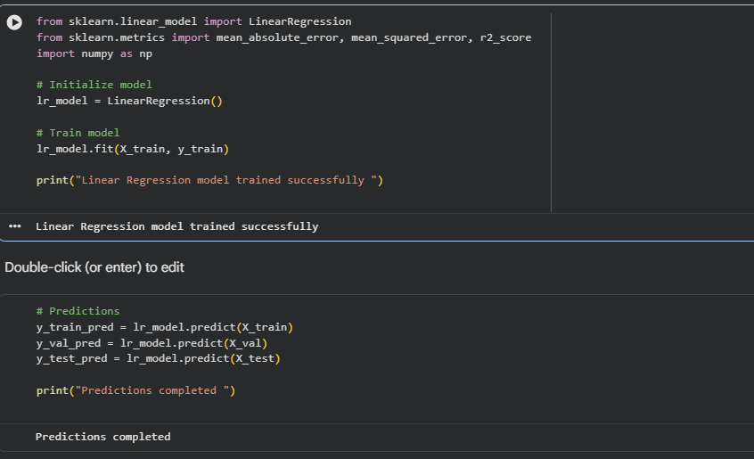
A Linear Regression model was implemented as the baseline forecasting model to predict energy consumption. The model was trained using the training dataset and used to generate predictions for the training, validation, and test sets. This baseline approach establishes a reference performance level, allowing evaluation of prediction accuracy using metrics such as MAE, RMSE, and R², and serves as a benchmark for comparison with more advanced models like Random Forest.

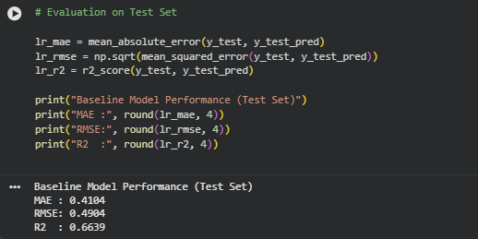
The Linear Regression baseline model achieved an MAE of 0.4104 and RMSE of 0.4904, indicating moderate prediction error.
With an R² score of 0.6639, the model explains approximately 66% of the variance in energy consumption.
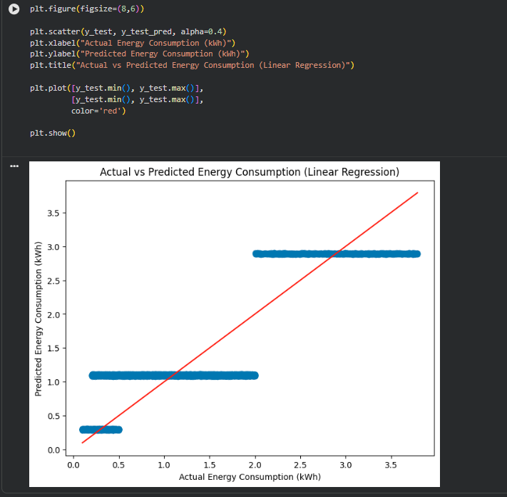
The scatter plot shows that predictions are clustered in horizontal bands rather than closely following the 45-degree reference line. This indicates that the Linear Regression model captures general trends but struggles to model finer variations in energy consumption.

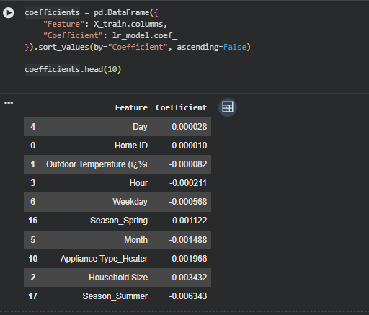

The coefficient analysis shows that most features have very small coefficient values, indicating limited individual impact on energy consumption in the linear model. No single feature strongly dominates the prediction, suggesting that energy usage is influenced by multiple factors collectively rather than one primary variable.

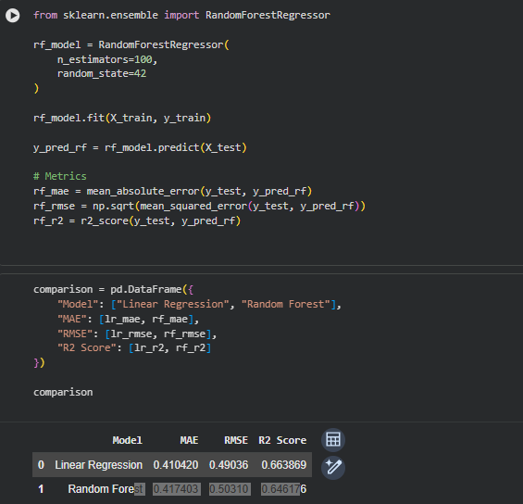

The comparison between Linear Regression and Random Forest shows that Linear Regression slightly outperformed Random Forest in terms of MAE, RMSE, and R² score. This suggests that the relationship between the features and energy consumption is largely linear in nature. Both models achieved moderate predictive performance, explaining approximately 65% of the variance in energy consumption.

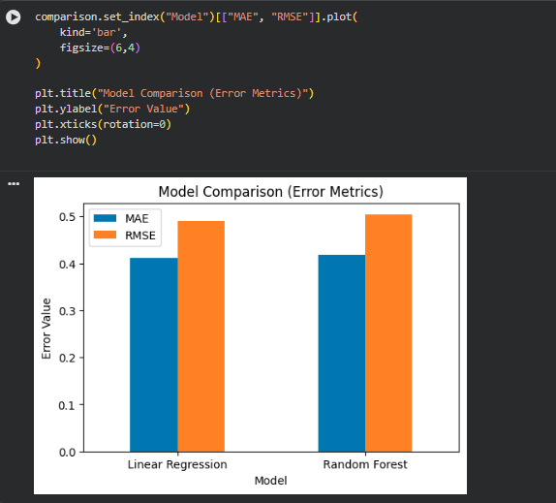

The error comparison chart shows that Linear Regression has slightly lower MAE and RMSE values compared to Random Forest. This indicates that the Linear Regression model performs marginally better in terms of prediction accuracy on the test set, suggesting that the underlying relationship in the dataset is largely linear.
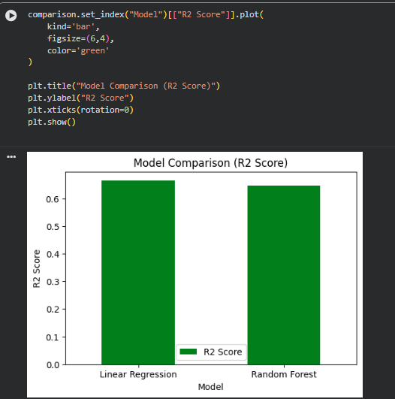

The R² comparison chart shows that Linear Regression achieves a slightly higher R² score than Random Forest, explaining about 66% of the variance in energy consumption. This indicates that the dataset follows a predominantly linear pattern, allowing the simpler linear model to perform marginally better than the more complex ensemble model.

